Greater Cambridge Local Plan
Briefing Note

Introduction

The Local Plan is updated every five years and sets the development agenda for the next 20 years. It is a critical document which sets out design and planning policies against which all local developments will be judged. The planners encourage as much feedback as possible, both positive and negative, and are committed to considering all responses. It is vital that communities like Boxworth make our voices heard, collectively and individually. If we do not then we can have no comeback if future developments adversely affect our village.

When making a comment you will be asked to log in or register if this is your first comment.

This note provides information on the Draft Local Plan, how to locate background on the sites directly affecting Boxworth and how to provide comments on the plan. The consultation period runs from 1 Dec 2025 to 26 Jan 2026.

To comment on the plans

Draft Local Plan
The plan sets out how the Greater Cambridge Shared Planning team and the local Councillors see the Cambridge area developing over the period to 2045. This is the link to the plan https://greatercambridgeplanning.org/local-plan

This link takes you to an interactive map which allows you to see detailed descriptions of all of the development sites included in the Draft Plan https://placemaker.greatercambridgeplanning.urbanintelligence.co.uk/p/document/5/?appid=fb3771f8fa0f42e2af8511978fd8ec62

An overall observation is that the Draft Local Plan does not consolidate the effect of all of the proposed developments on the infrastructure of the area. For example, housing and commercial developments will create additional traffic but there is no attempt to demonstrate how that traffic will be accommodated by the existing road networks, nor any discussion of new road provisions.

Similarly, flood risks are not consolidated and explanations provided on how these risks will be managed to prevent flooding of the Swavesey drainage channels to the river Ouse.

Cambourne North Housing Development

Cambourne North will be developed over the next 20 years and eventually reach 13,000 properties. It will be the largest urban development in the area after Cambridge and Peterborough. It will be centred around a new station on East West rail, North of the A428. When fully developed it will approach within 400/500m of Elsworth and Knapwell and be surrounded by a newly planted Cambourne Forest. This link takes you to the site description. https://consultations.greatercambridgeplanning.org/draft-greater-cambridge-local-plan-consultation/site-allocations/new-settlements/policy-scbn

Comments can be left by clicking on the ‘Comment’ button on the webpage.

Cambourne North will be developed, it has been included in the Local Plan for many Years.

Boxworth, Elsworth, and Knapwell will experience increased traffic due to commuters traveling to and from the site for the station, work, and other facilities.
- The plans do not show any additional road capacity to handle the additional volumes and refer only to mitigation in the form of traffic calming and signage.
- Comments to the consultation could emphasise the need for traffic management to be included in the next round of the consultation.

Logistic Sites along the A14

Sites allocated in the Local Plan

Two sites have been included in the Draft Local Plan as suitable for development.

Land to the South of Cambridge Services, Jaynic. This is the link to the relevant webpage https://consultations.greatercambridgeplanning.org/draft-greater-cambridge-local-plan-consultation/site-allocations/rest-rural-area/policy-srra-2

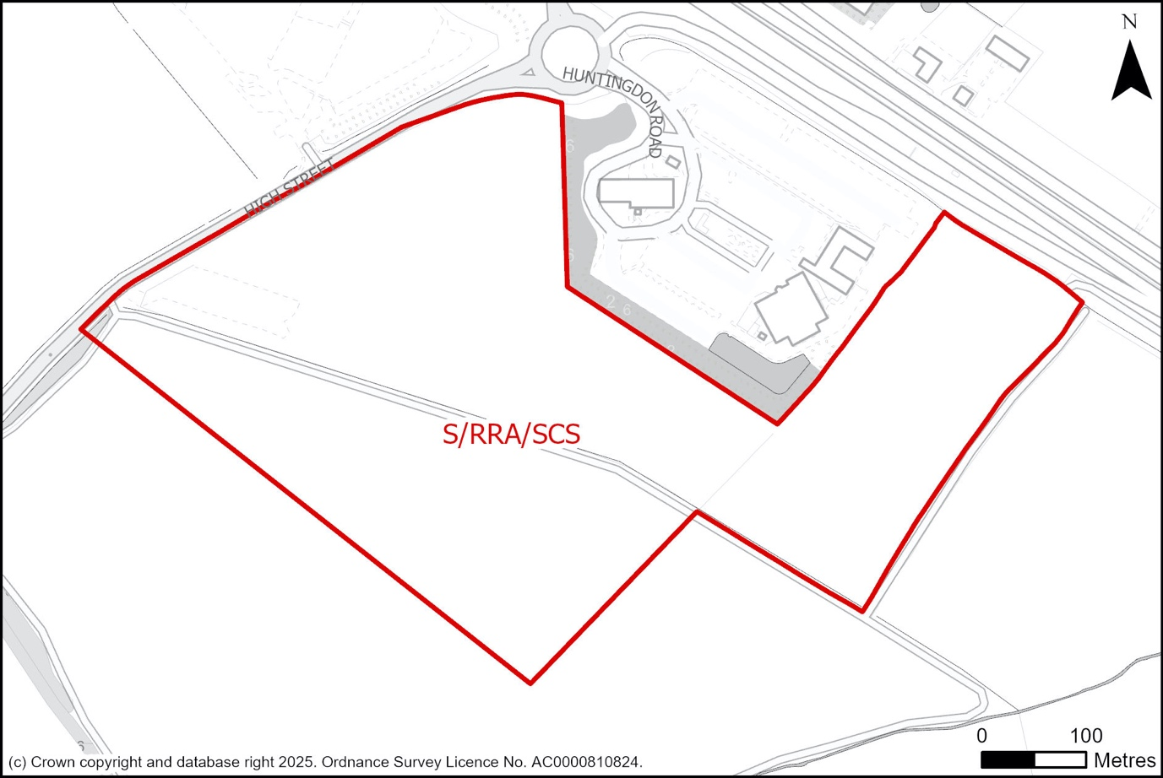

This is 25 Hectares, 90,000sqm of light industrial or logistics space. The planners suggest that it should consist of small to medium size units. If the height of the buildings are kept to 10/12m then this development could resemble the Buckingway site on the opposite side of the A14. It will include provision for 150 additional lorry parking spaces immediately adjacent to the A14 and the Cambridge Services.

The developers currently show access off Boxworth Road.
- This should be resisted and access restricted to either an entrance of the existing A14 slip road and/or the roundabout at the services. Comments to the Local Plan could emphasise this point.
- Comments should stress the importance of restricting building heights and the need to focus on local needs.

Land to the North of the A1307 at Bar Hill, Slate Hall Farm. This is the link to the webpage https://consultations.greatercambridgeplanning.org/draft-greater-cambridge-local-plan-consultation/site-allocations/rest-rural-area/policy-sshf-land

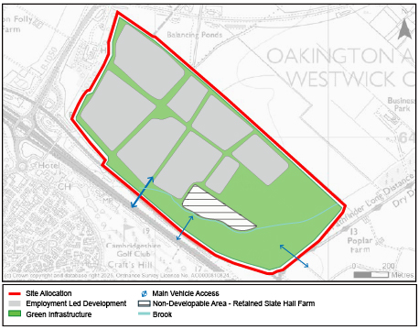

This is a large site of 113 hectares providing up to 220,000sqm of light industrial/logistics space. The proposal is to develop this in stages and to adapt the development to any changing needs, including introducing office space.

There are traffic access issues at this site and real concerns over the capacity of the A1307 local road and the junctions onto the A14 coping.

This site is the furthest away from Boxworth. Impact on us will come from general increases in traffic. The Draft Plan is silent on how this should be managed.

Sites not allocated in the Local Plan

Two sites have been put forward along the A14 which the planners have not included in the Draft Plan. This does not mean the developers won’t submit planning applications but it does mean that the presumption is that permission will be declined. The developers will in all likelihood appeal. Newlands, one of the developers, have recently won permission to develop on appeal on a site at Thrapston.

Land to the North West of Cambridge Services, Newlands.

As this is not included in the Draft Local Plan there is no specific webpage but comments can be left here https://consultations.greatercambridgeplanning.org/draft-greater-cambridge-local-plan-consultation/site-allocations/rest-rural-area
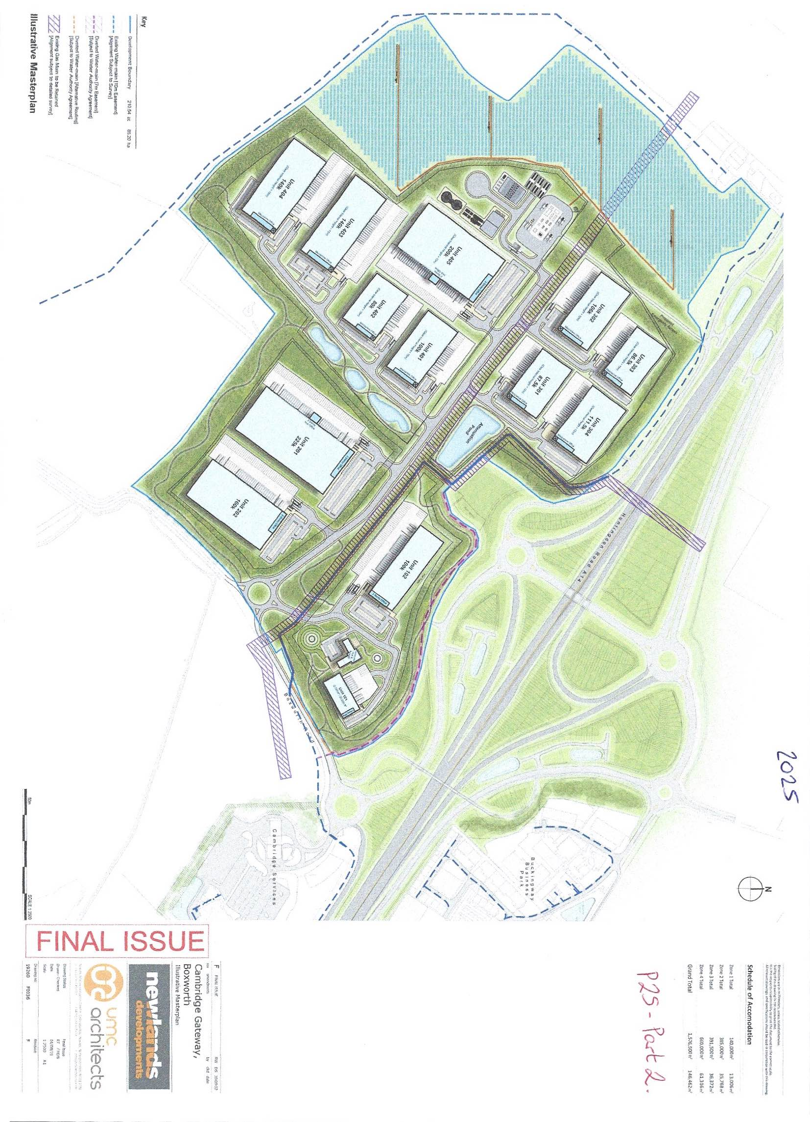
Newlands are proposing to build on 220 acres just to the west of Boxworth Road. Their proposal is for ‘big boxes’ up to 24m high. These buildings will dominate the landscape and generate 4,500 vehicle journeys a day (our estimate).

The schematic below shows that the largest of the proposed buildings will exceed the height of the ridge running from Boxworth to Connington.
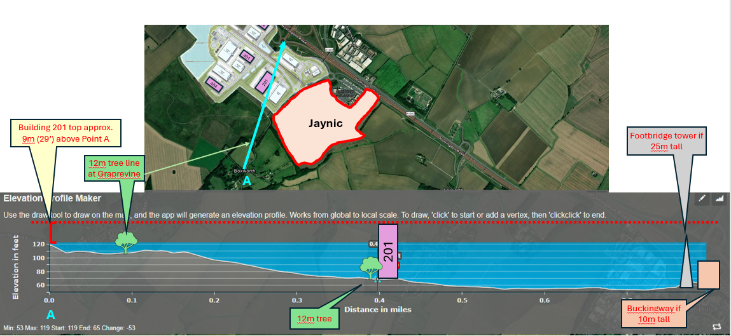

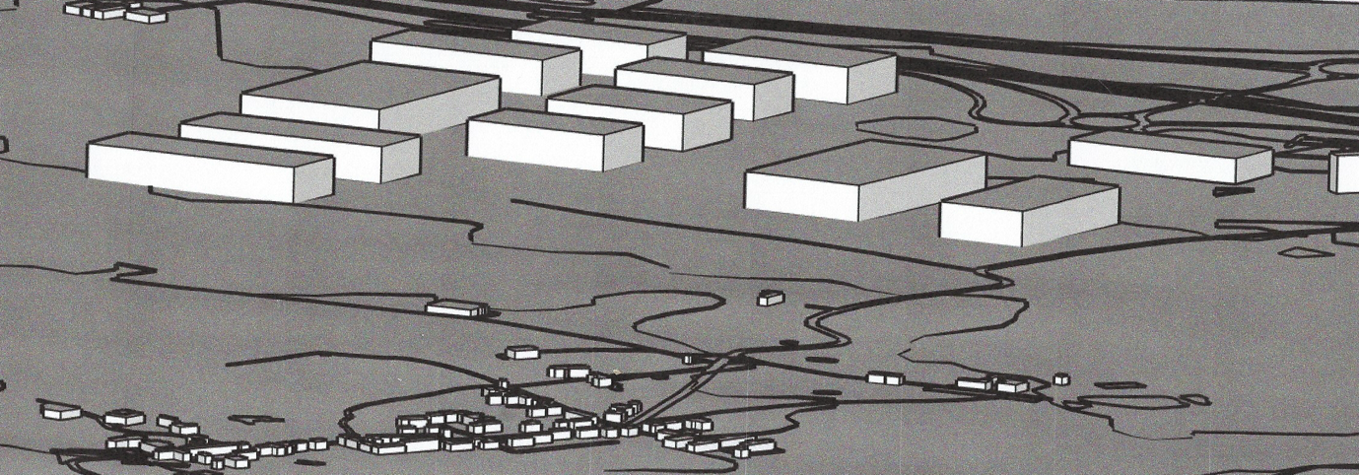

This is a 3D representation of the original Newlands buildings layout.

The size and scale of this development will dominate the environment. It is not designed to meet the local needs of Greater Cambridge but to fulfil a national and regional function.

Comments submitted to the Local Plan Consultation could focus on:

- The inappropriate size and scale
- The development meeting national and regional, not local needs
- Traffic management would also be a significant concern.

Land North of A14, J25, Bar Hill (Noon Folly Farm), Tritax

This does not affect Boxworth directly but is similar to Newlands in that the developer is proposing ‘big boxes’. Access will be from the B1050, Longstanton Road and is causing concern for the capacity of the junctions surrounding it to cope with the volumes it generates.

