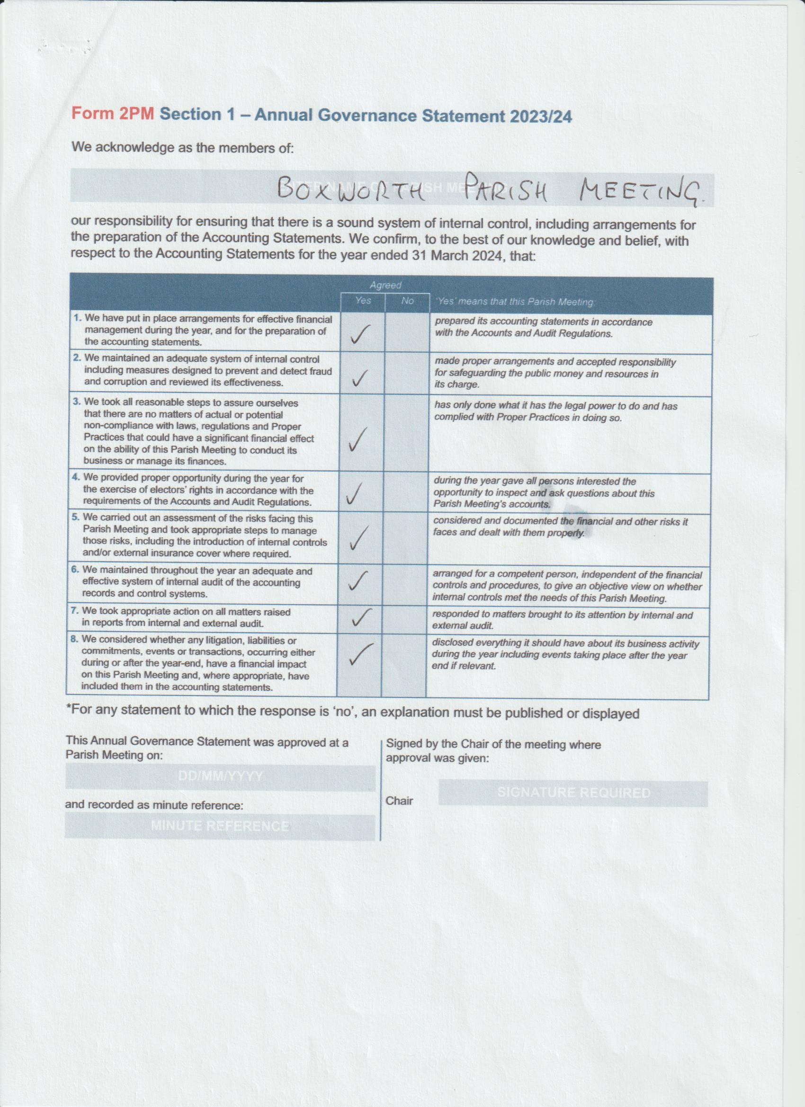
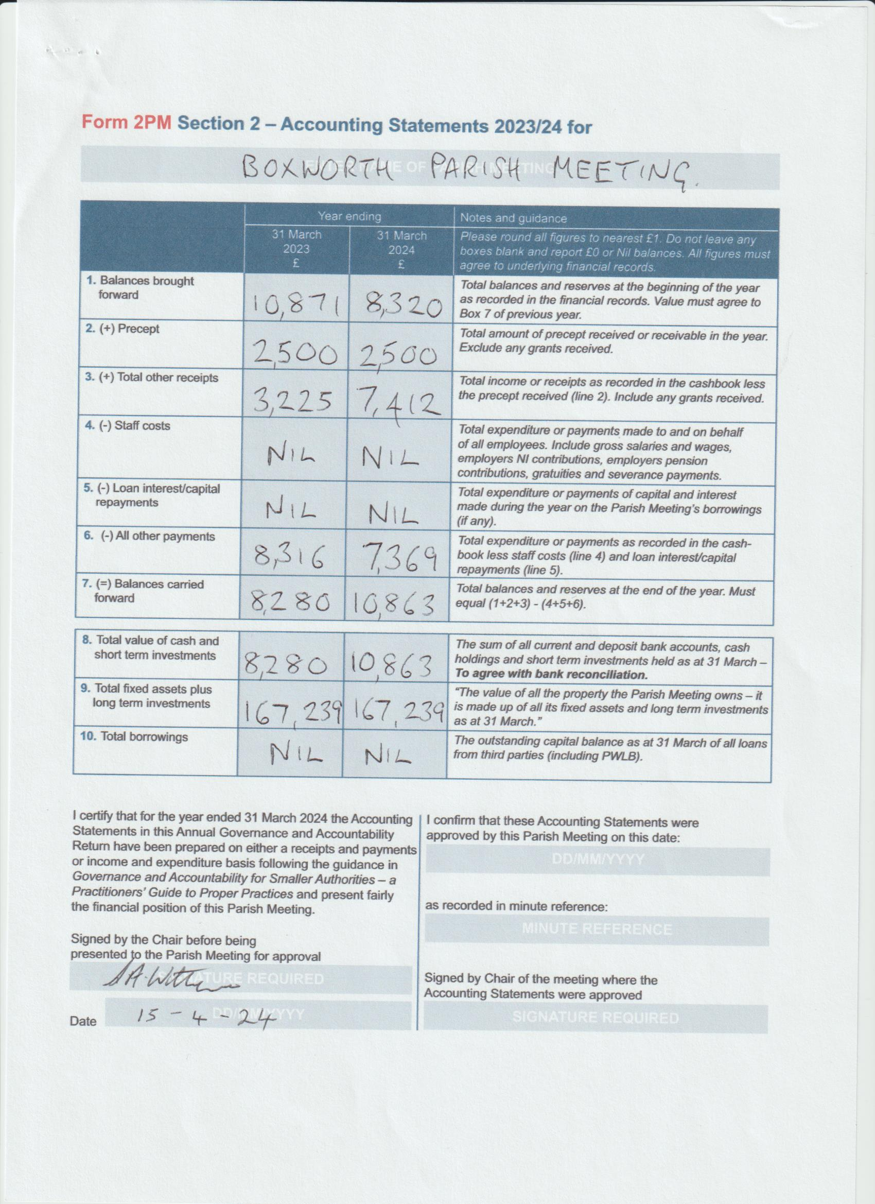

 | Boxworth Parish Accounts For 2023/24
 |  | 2021/22 | 2022/23 | 2023/4
 | Opening Balance | £14,425 | £10,868 | £8,320
 | Income
 | Precept | - | £2,500 | £2,500
 | Hall/Equipment Hire | £165 | £1,146 | £5,395
 | Village Events (Fireworks/Quiz Night/etc) | -£66 | £498 | £1,935
 | Covid Grant | £2,667
 | Interest |  | £14 | £82
 | Total Income: | £2,766 | £4,158 | £9,912
 | Expenditure
 | Parish Expenditure
 | Insurance | £154 | £238 | £238
 | CAPALC membership | £178 | £178 | £184
 | Elsworth School donation | £250 | £250 | £250
 | PCC donation | £250 | £250 | £250
 | Information Commissioner | £35 | £35 | £35
 | Bank charges |  | £61 | £60
 | Paint for sign |  | £51
 | Road Watch donation | £200 |  | £200
 | Total Parish Expenditure: | £1,067 | £1,063 | £1,217
 | Village Hall Expenditure
 | Water | £424 | £456 | £544
 | Insurance | £363 | £420 | £432
 | ACRE membership |  |  | £65
 | General Maintenance | £974 |  | £390
 | Electricity | £358 | £415 | £2,667
 | H&S/ Fire Audit and Protection | £190 | £96 | £361
 | Broadband |  | £200 | £279
 | Booking System |  | £165 | £165
 | Hall Expenses | £418 | £340 | £156
 | Shed | £400 | £326
 | Gazebo | £191
 | Path/Parking Area |  | £2,520
 | Coronation mugs |  | £460
 | Defibrillator | £1,938 | £245 | £84
 | Toilet repair |  |  | £120
 | PAT report |  |  | £57
 | Electrical maintenance & improvements |  |  | £832
 | Total Village Hall Expenditure: | £5,256 | £5,643 | £6,152
 | Total Expenditure | £6,323 | £6,706 | £7,369
 | Total Income - Total Expenditure | -£3,557 | -£2,548 | £2,543
 | Closing Balance | £10,868 | £8,320 | £10,863

